FOLD 1 │ HERO + LEAD GENERATION FORM
Sales Pod Landing Page

Reference:
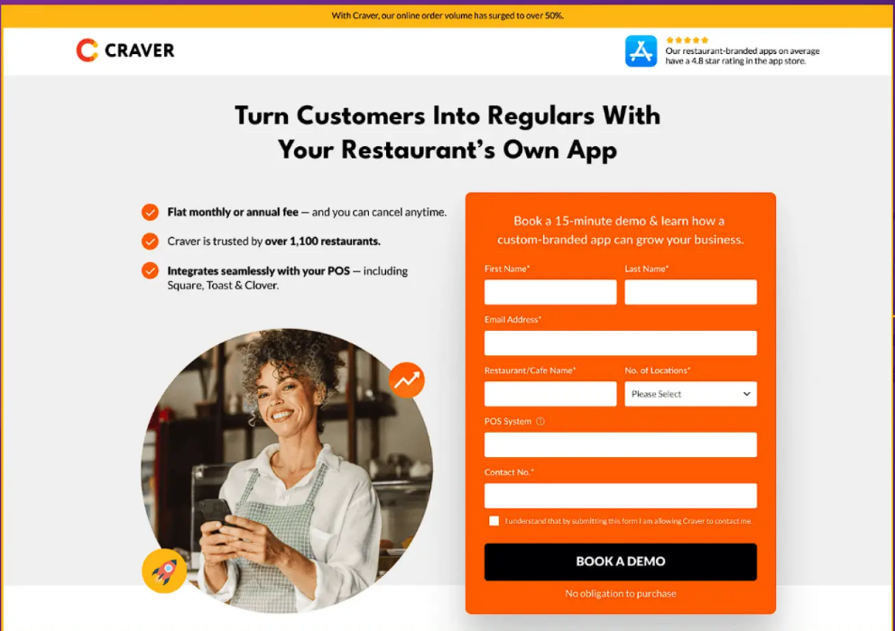

Heading:
The AI-powered Engine for High-Performance Sales Teams.
Deploy autonomous Sales Pods that source, screen, and engage your ideal customers. Scale your revenue without scaling your headcount.

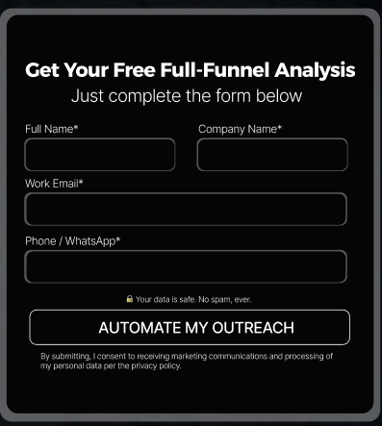

FOLD 2 │

The ultimate growth shortcut for modern sales teams.
Scaling your revenue is now as simple as turning on a Pod. Step into the next generation of automated excellence.

500+  Leads Automated | 70%  Faster Lead Response Time | 8 hrs  Saved Per Rep / Week

Reference:

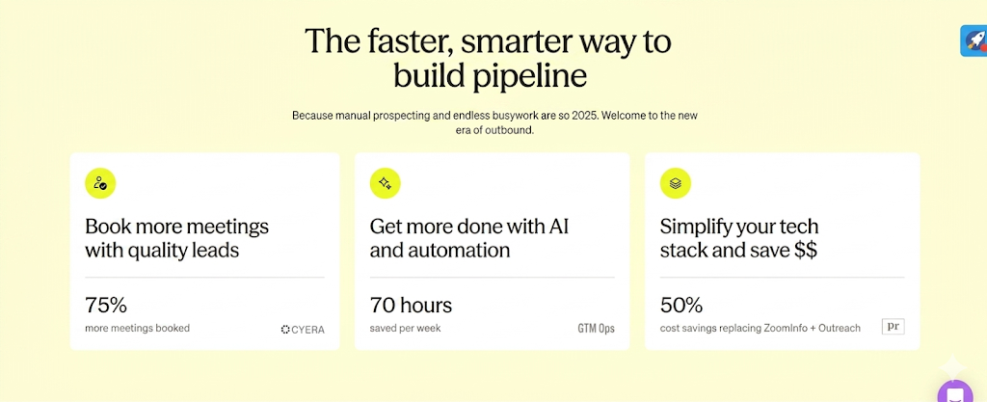

FOLD 3 │ Demo Video


Fold Label: Product Demo
Main Headline: Explore the Product

Main Heading Key Features of AI-Powered Marketing Automation
From finding the right prospects to nurturing intent and updating your CRM — SalesPod automates the entire outbound sales workflow.

- Heading - Lead Generation With AI
Subhead - SalesPod identifies, filters, and delivers high-quality leads tailored to your ICP.
Understand Your ICP
Define your ideal customer based on industry, company size, geography, buying signals, and decision-makers.
Scrape Relevant Leads Across the Internet
Continuously scans LinkedIn, business databases, and public sources to identify matching prospects.
Generate Sales-Ready Leads
Filters, enriches, and organizes lead data for immediate outreach.

- Multi-Channel Outreach That Scales Personalization
Reach prospects across channels with messaging tailored to your audience.
Launch Outreach Across Multiple Channels
Connect through Email, AI Voice Calls, LinkedIn, WhatsApp, and more.
Customize Messaging for Every Audience
Set your tone, messaging flow, and campaign strategy based on your ICP.
Train AI Agents to Match Your Style
AI agents adapt to your communication style, language, and conversation patterns.

- Intelligent Lead Nurturing That Tracks Intent
SalesPod follows every conversation and identifies the right time to involve your sales team.
Monitor Conversations Across Channels
Tracks emails, calls, LinkedIn messages, WhatsApp chats, and more in real time.
Follow Up Based on Buyer Behavior
Sends contextual follow-ups based on engagement stage and customer responses.
Handoff High-Intent Leads Instantly
Routes qualified opportunities to your sales team with full conversation context.

4. Automated CRM Updates and Smarter Lead Scoring
Reduce manual work while prioritizing the leads most likely to convert.
Auto-Update CRM Entries
Syncs interactions, responses, and lead activity automatically into your CRM.
Analyze Buyer Sentiment
Understands tone, hesitation, engagement, and intent across conversations.
Score Leads Based on Intent
Ranks leads dynamically using engagement quality and buying signals.

5. Intelligent Dashboards for Better Sales Decisions
Turn sales activity into actionable insights and measurable outcomes.
Capture Data Across the Sales Journey
Tracks outreach, engagement, conversions, and pipeline activity in one place.
Analyze Campaign Performance Automatically
Measures what’s working across channels, messaging, and outreach flows.
Break Down Insights by KPIs
Monitor metrics like response rates, meetings booked, conversions, and ROI.

FOLD 7 │

Move Leads Faster Through Your Pipeline
SalesPod combines AI-powered lead generation, multi-channel outreach, and intelligent nurturing to help sales teams scale conversations without scaling manual effort.

3s

First Contact
Lead enters. Outreach begins automatically across channels.

3×

More Replies
Multi-channel outreach consistently outperforms single-channel campaigns.

60%

Less Manual Work
Sales reps focus only on leads that show real engagement and intent.

40%

More Meetings Booked
Convert more opportunities from the leads your team already has.

Why Sales Teams Use SalesPod

ICP-Matched Leads
Qualified leads tailored to your target audience and buying intent.

Multi-Channel Outreach
Email, LinkedIn, AI Voice Calls, WhatsApp, and more — in one sequence.

Smarter Sales Handoffs
Sales teams step in only when leads are warm and conversation-ready.

Intent-Driven Prioritization
Identify high-intent prospects before your team makes the call.

CTA: Download the Feature Guide →
Reference:
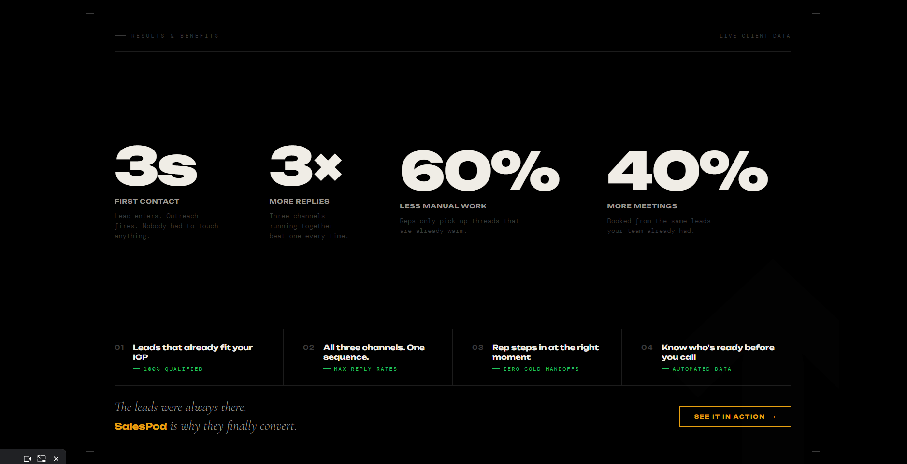

FOLD 8 │ Why Scalepods

Heading: Manual vs Automated Sales Workflow

Sub- text: Integrate Sales Automation in your workflow to drive exponential results.

Automated SalesPod Workflow | Existing Manual System Workflow
High-intent ICP lead lists populate automatically via continuous web scraping. | Reps waste hours manually hunting for data from scratch.
Tailored campaigns launch simultaneously across email, LinkedIn, WhatsApp, and AI voice. | Outreach stalls on basic emails that get easily ignored in crowded inboxes.
Reps step in exclusively when a lead shows clear, cross-channel buying intent. | Hot opportunities freeze while reps manually hunt through scattered replies.
The CRM updates itself in real time using precise lead scores based on human sentiment and hesitation. | Pipeline data breaks down due to total reliance on what reps remember to log.
Clear success metrics and exact ROI unlock inside one centralized dashboard. | Growth opportunities vanish because nobody knows which channel is actually working.

Your team is good at selling. SalesPod makes sure they only talk to people who are ready.

See how it works →

FOLD 10 Voices — Client Testimonials

Headline: Teams that made the switch.

Direct Feedback:
Anuj Ruia (Co-Founder, BECO): Fast, accurate, and blends into daily operations without friction. Felt like a senior team member rather than a tool.
Sharan Lekhi (Founder, Krafty Animations): "Game-changer. Flows run flawlessly. Our team focuses only on what moves revenue — everything else just happens."
Shreyansh Jaiswal (Founder, HobbyFi): "Smooth setup. Replaced three tools in one go. Improvements showed in the very first week."

FOLD 11 Questions · Before You Decide

FAQs
01. What is sales automation?
Traditionally, sales automation meant setting up static email sequences and auto-filling contact fields. ScalePods transforms this definition entirely. With SalesPod, sales automation becomes an end-to-end, autonomous sales pipeline engine. Instead of your team managing software, the SalesPod actively executes the work: it scrapes live internet data to find your exact ICP, launches coordinated campaigns across Email, LinkedIn, WhatsApp, and Voice, and uses AI in sales to handle lead nurturing until a meeting is ready to be booked.

02. What is the difference between sales automation and CRM?
A CRM (Customer Relationship Management) system like HubSpot or Salesforce is a database—it stores your contact history and logs deal stages. SalesPod is the active execution engine that brings that data to life. While traditional B2B sales automation requires you to manually log activities, SalesPod works in the background: it dynamically pulls new leads from the web, executes multi-channel outreach, reads prospect replies using sentiment analysis, and automatically updates your CRM records and lead scores in real time without human intervention.

03. What is the difference between sales automation and marketing automation?
Marketing automation software focuses on the top of the funnel, using a "one-to-many" approach like generic newsletters or automated social posts to capture broad interest. SalesPod is a specialized outreach automation tool built for hyper-personalized, "one-to-one" B2B sales development. It engages specific decision-makers directly across their preferred communication apps (Email, LinkedIn, WhatsApp, and Voice) using custom-trained bots that mimic your exact brand style to move leads into deep sales conversations.

04. Will AI replace sales professionals?
No. AI sales tools are built to eliminate administrative friction, not human relationship builders. B2B buyers still require human trust, nuance, and strategic negotiation to finalize a partnership. SalesPod is designed to automate the grueling 80% of the sales cycle—the manual prospecting, cold outreach, follow-ups, and CRM logging. By taking over the tedious groundwork, SalesPod empowers your reps to spend 100% of their time doing what they do best: holding high-intent conversations and closing deals.

05. Is SalesPod GDPR and data compliance ready?
Yes. ScalePods is engineered with enterprise-grade data security and strict adherence to global privacy laws, including GDPR and CCPA. The SalesPod relies on compliant, opt-in targeted web scraping standards and operates within the strict terms of service for platforms like WhatsApp and LinkedIn. Because every outreach flow includes seamless opt-out mechanisms, you get high-velocity pipeline growth while maintaining complete data compliance, with all configurations fully managed by our team during your setup.

.

